**Multidisciplinary Capstone Design**

**Peer Review Documentation for Students**

1. Go to this address: <http://senior-evaluate.cloudapp.net/>
2. Please note that this website works best with Chrome
3. Login using   
   Username : **Check-Marq USERNAME**  
   Password : **9 digit** **MUID with leading 0’s**

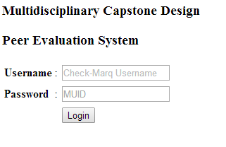

1. Now select a team member from the list and click “Evaluate” to evaluate the selected member.

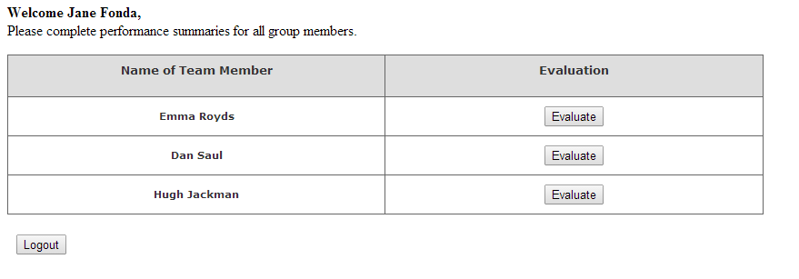

1. After filling out the evaluation form, submit this form by clicking “Submit”.

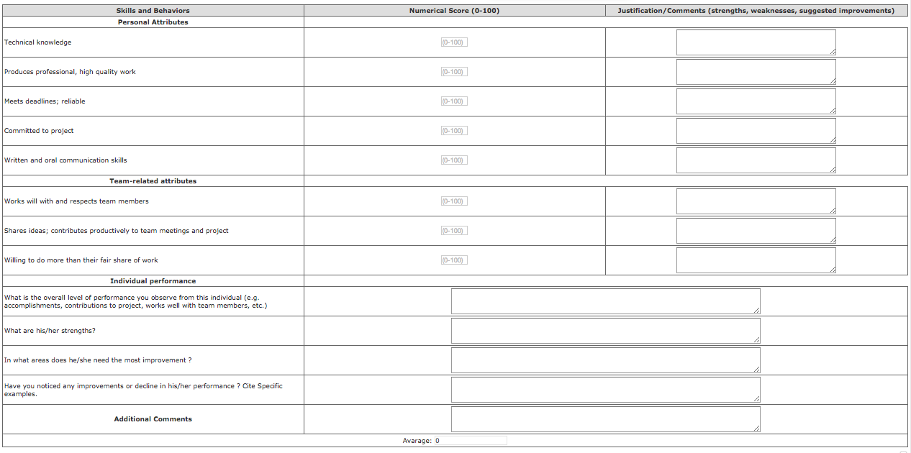

1. Now you can select another member to evaluate if there are any more in the list. Otherwise, you can log out from the application. If you wish, you can come again later to complete the evaluation of your other team members.

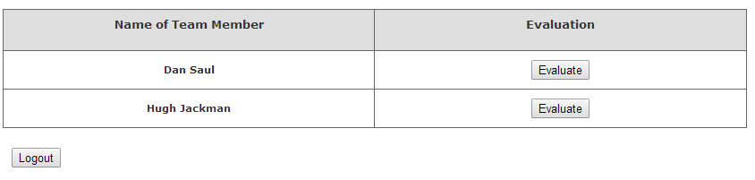

Please contact with Dr. Sheikh Ahamed ([sheikh.ahamed@marquette.edu](mailto:sheikh.ahamed@marquette.edu)) or Veli Melih Bilen (velimelih.bilen@marquette.edu) if you have any question.